ASSIGNMENT: 5

- Draw a simple diagram showing the pin layout of an RJ-45 connector and label the color codes for the T568A and T568B Ethernet wiring standards.

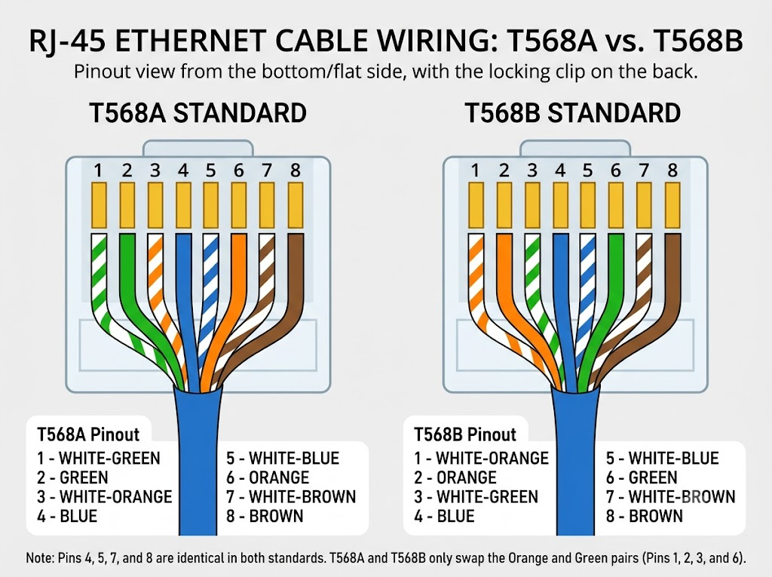

- Create a table comparing the key specifications of Ethernet standards 10BASE-T, 100BASE-TX, and 1000BASE-T, including speed, cable type, maximum cable length, and connector type.

Ethernet Standards Comparison
Specification | 10BASE-T | 100BASE-TX | 1000BASE-T
Speed | 10 Mbps | 100 Mbps | 1000 Mbps (1 Gbps)
Cable Type | Cat3 or Cat5 UTP | Cat5 UTP or better | Cat5e or Cat6 UTP
Maximum Cable Length | 100 meters | 100 meters | 100 meters
Connector Type | RJ-45 | RJ-45 | RJ-45

- Given a scenario where you need to connect two laptops directly using Ethernet, explain which cable (straight-through or crossover) you would use and why.<br><br><em><strong>Hint:</strong> Think about how transmit and receive pairs are wired in each cable type.</em>

Scenario: Laptop-to-Laptop Connection
Scenario | Cable to Use | Reason
Laptop to Laptop (Direct) | Crossover Cable | Transmit and receive pairs are swapped, allowing two devices to communicate directly.

Types of Ethernet Cables
Cable Type | Wiring | Use Case
Straight-Through | Same wiring order at both ends (T568B–T568B) | Connects different devices, such as a PC to a switch.
Crossover | Different wiring orders at both ends (T568A–T568B) | Traditionally connects similar devices, such as PC to PC or switch to switch.

- List three real-world devices in your home or college that use Ethernet connections, and for each, specify the likely Ethernet standard (e.g., 100BASE-TX, 1000BASE-T) they support.

Ethernet Devices at Home/College
Device | Likely Ethernet Standard | Reason
Home Wi-Fi Router | 1000BASE-T (Gigabit) | Modern routers often support Gigabit Ethernet for high-speed internet connectivity.
Desktop PC / College Lab Computer | 1000BASE-T (Gigabit) | Most modern motherboards include built-in Gigabit Ethernet ports.
Smart TV / Gaming Console | 100BASE-TX or 1000BASE-T | Older models may support 100 Mbps, while newer models may support 1 Gbps.

